**RUBY AND RAILS**

C:\Users\Administrador.000\Desktop>rails new Ejemplo_RubyRails --> Crear Proyecto Rails

C:\Users\Administrador.000\Desktop>cd Ejemplo_RubyRails --> Entrar a la carpeta de Proyecto Rails creado

C:\Users\Administrador.000\Desktop>rail server --> Iniciar Servidor Rails

-->Porbar iniciando el explorador en localhost:3000

-->Salir de rails con Ctrl+C para trabjar con los scaffolds

C:\Users\Administrador.000\Desktop\Ejemplo_RubyRails>rails generate scaffold City name:string zip_code:integer state:string --> Crear scaffold

C:\Users\Administrador.000\Desktop\Ejemplo_RubyRails>rails generate scaffold User name:string email:string type_user:integer city:references --> Crear scaffold

--> Es importante que los scaffolds sean creados con los términos en inglés y en singular.

C:\Users\Administrador.000\Desktop\Ejemplo_RubyRails>rails destry scaffold User --> para borrar el scaffold User

C:\Users\Administrador.000\Desktop>rail server --> Reiniciar Servidor Rails

--> Models, Controllersy Views, en el código son los items que más se usan

C:\Users\Administrador.000\Desktop\Ejemplo_RubyRails>rake db:migrate -->Migrar los cambios en la base de datos

C:\Users\Administrador.000\Desktop\Ejemplo_RubyRails>rails server -->Reiniciar Servicio Rails

-->En el explorador

http://localhost:3000/cities para City

http://localhost:3000/users para User

--sin cerrar el actual cmd, abro otro cmd para usarlo de consola sin cerrar el servicio

C:\Users>cd Administrador.000

C:\Users\Administrador.000>cd Desktop

C:\Users\Administrador.000\Desktop>cd Ejemplo_RubyRails

C:\Users\Administrador.000\Desktop\Ejemplo_RubyRails>rails console

Loading development environment (Rails 5.1.6)

irb(main):001:0> City.all

City Load (0.0ms) SELECT "cities".* FROM "cities" LIMIT ? [["LIMIT", 11]]

=> #<ActiveRecord::Relation [#<City id: 1, name: "Bogotá", zip_code: 110311, state: "Bogotá D.C.", created_at: "2018-09-13 00:31:12", updated_at: "2018-09-13 00:31:12">, #<City id: 2, name: "Medellín", zip_code: 123456, state: "Antioquia", created_at: "2018-09-13 00:32:00", updated_at: "2018-09-13 00:32:00">]>

irb(main):002:0> User.all

User Load (0.0ms) SELECT "users".* FROM "users" LIMIT ? [["LIMIT", 11]]

=> #<ActiveRecord::Relation [#<User id: 1, name: "Ivonne Sánchez", email: "ivonneandreas@hotmail.com", type_user: 1, city_id: 1, created_at: "2018-09-13 00:33:48", updated_at: "2018-09-13 00:33:48">, #<User id: 2, name: "Mariana Vega", email: "marisvegas@hotmail.com", type_user: 2, city_id: 2, created_at: "2018-09-13 00:34:57", updated_at: "2018-09-13 00:34:57">]>

irb(main):003:0> user.find(2)

NameError: undefined local variable or method `user' for main:Object

from (irb):3

irb(main):004:0> User.find(2)

User Load (0.0ms) SELECT "users".* FROM "users" WHERE "users"."id" = ? LIMIT ? [["id", 2], ["LIMIT", 1]]

=> #<User id: 2, name: "Mariana Vega", email: "marisvegas@hotmail.com", type_user: 2, city_id: 2, created_at: "2018-09-13 00:34:57", updated_at: "2018-09-13 00:34:57">

irb(main):005:0> User.find(1)

User Load (0.0ms) SELECT "users".* FROM "users" WHERE "users"."id" = ? LIMIT ? [["id", 1], ["LIMIT", 1]]

=> #<User id: 1, name: "Ivonne Sánchez", email: "ivonneandreas@hotmail.com", type_user: 1, city_id: 1, created_at: "2018-09-13 00:33:48", updated_at: "2018-09-13 00:33:48">

irb(main):006:0> User.find(1).city

User Load (0.0ms) SELECT "users".* FROM "users" WHERE "users"."id" = ? LIMIT ? [["id", 1], ["LIMIT", 1]]

City Load (0.0ms) SELECT "cities".* FROM "cities" WHERE "cities"."id" = ? LIMIT ? [["id", 1], ["LIMIT", 1]]

=> #<City id: 1, name: "Bogotá", zip_code: 110311, state: "Bogotá D.C.", created_at: "2018-09-13 00:31:12", updated_at: "2018-09-13 00:31:12">

irb(main):007:0> User.find(1).city.name

User Load (0.0ms) SELECT "users".* FROM "users" WHERE "users"."id" = ? LIMIT ? [["id", 1], ["LIMIT", 1]]

City Load (0.0ms) SELECT "cities".* FROM "cities" WHERE "cities"."id" = ? LIMIT ? [["id", 1], ["LIMIT", 1]]

=> "Bogotá"

C:\Users\Administrador.000\Desktop>rails new Ejemplo_RubyRails --> Crear Proyecto Rails

C:\Users\Administrador.000\Desktop>cd Ejemplo_RubyRails --> Entrar a la carpeta de Proyecto Rails creado

C:\Users\Administrador.000\Desktop>rail server --> Iniciar Servidor Rails

-->Porbar iniciando el explorador en localhost:3000

-->Salir de rails con Ctrl+C para trabjar con los scaffolds

C:\Users\Administrador.000\Desktop\Ejemplo_RubyRails>rails generate scaffold City name:string zip_code:integer state:string --> Crear scaffold

C:\Users\Administrador.000\Desktop\Ejemplo_RubyRails>rails generate scaffold User name:string email:string type_user:integer city:references --> Crear scaffold

--> Es importante que los scaffolds sean creados con los términos en inglés y en singular.

C:\Users\Administrador.000\Desktop\Ejemplo_RubyRails>rails destry scaffold User --> para borrar el scaffold User

C:\Users\Administrador.000\Desktop>rail server --> Reiniciar Servidor Rails

--> Models, Controllersy Views, en el código son los items que más se usan

C:\Users\Administrador.000\Desktop\Ejemplo_RubyRails>rake db:migrate -->Migrar los cambios en la base de datos

C:\Users\Administrador.000\Desktop\Ejemplo_RubyRails>rails server -->Reiniciar Servicio Rails

-->En el explorador

http://localhost:3000/cities para City

http://localhost:3000/users para User

--sin cerrar el actual cmd, abro otro cmd para usarlo de consola sin cerrar el servicio

C:\Users>cd Administrador.000

C:\Users\Administrador.000>cd Desktop

C:\Users\Administrador.000\Desktop>cd Ejemplo_RubyRails

C:\Users\Administrador.000\Desktop\Ejemplo_RubyRails>rails console

Loading development environment (Rails 5.1.6)

irb(main):001:0> City.all

City Load (0.0ms) SELECT "cities".* FROM "cities" LIMIT ? [["LIMIT", 11]]

=> #<ActiveRecord::Relation [#<City id: 1, name: "Bogotá", zip_code: 110311, state: "Bogotá D.C.", created_at: "2018-09-13 00:31:12", updated_at: "2018-09-13 00:31:12">, #<City id: 2, name: "Medellín", zip_code: 123456, state: "Antioquia", created_at: "2018-09-13 00:32:00", updated_at: "2018-09-13 00:32:00">]>

irb(main):002:0> User.all

User Load (0.0ms) SELECT "users".* FROM "users" LIMIT ? [["LIMIT", 11]]

=> #<ActiveRecord::Relation [#<User id: 1, name: "Ivonne Sánchez", email: "ivonneandreas@hotmail.com", type_user: 1, city_id: 1, created_at: "2018-09-13 00:33:48", updated_at: "2018-09-13 00:33:48">, #<User id: 2, name: "Mariana Vega", email: "marisvegas@hotmail.com", type_user: 2, city_id: 2, created_at: "2018-09-13 00:34:57", updated_at: "2018-09-13 00:34:57">]>

irb(main):003:0> user.find(2)

NameError: undefined local variable or method `user' for main:Object

from (irb):3

irb(main):004:0> User.find(2)

User Load (0.0ms) SELECT "users".* FROM "users" WHERE "users"."id" = ? LIMIT ? [["id", 2], ["LIMIT", 1]]

=> #<User id: 2, name: "Mariana Vega", email: "marisvegas@hotmail.com", type_user: 2, city_id: 2, created_at: "2018-09-13 00:34:57", updated_at: "2018-09-13 00:34:57">

irb(main):005:0> User.find(1)

User Load (0.0ms) SELECT "users".* FROM "users" WHERE "users"."id" = ? LIMIT ? [["id", 1], ["LIMIT", 1]]

=> #<User id: 1, name: "Ivonne Sánchez", email: "ivonneandreas@hotmail.com", type_user: 1, city_id: 1, created_at: "2018-09-13 00:33:48", updated_at: "2018-09-13 00:33:48">

irb(main):006:0> User.find(1).city

User Load (0.0ms) SELECT "users".* FROM "users" WHERE "users"."id" = ? LIMIT ? [["id", 1], ["LIMIT", 1]]

City Load (0.0ms) SELECT "cities".* FROM "cities" WHERE "cities"."id" = ? LIMIT ? [["id", 1], ["LIMIT", 1]]

=> #<City id: 1, name: "Bogotá", zip_code: 110311, state: "Bogotá D.C.", created_at: "2018-09-13 00:31:12", updated_at: "2018-09-13 00:31:12">

irb(main):007:0> User.find(1).city.name

User Load (0.0ms) SELECT "users".* FROM "users" WHERE "users"."id" = ? LIMIT ? [["id", 1], ["LIMIT", 1]]

City Load (0.0ms) SELECT "cities".* FROM "cities" WHERE "cities"."id" = ? LIMIT ? [["id", 1], ["LIMIT", 1]]

=> "Bogotá"

Para que no muestre la referencia de la ciudad sino el nombre cambiamos en views city por city.name

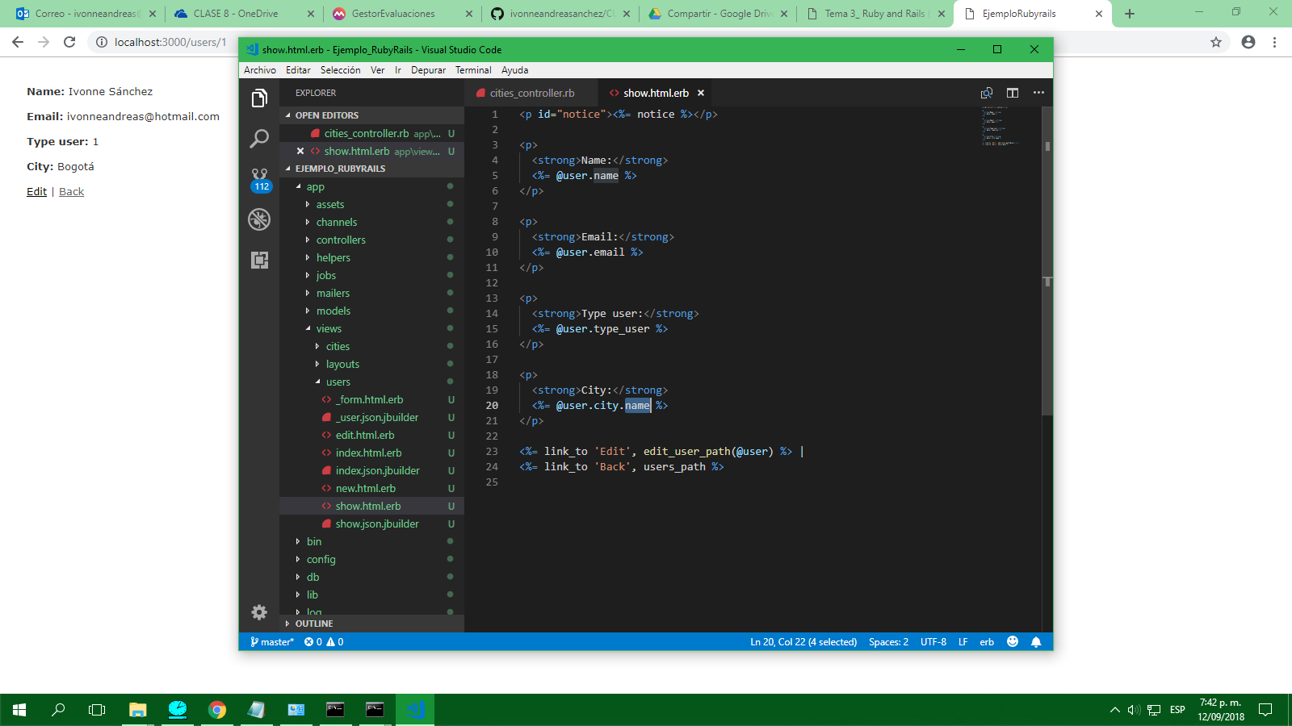

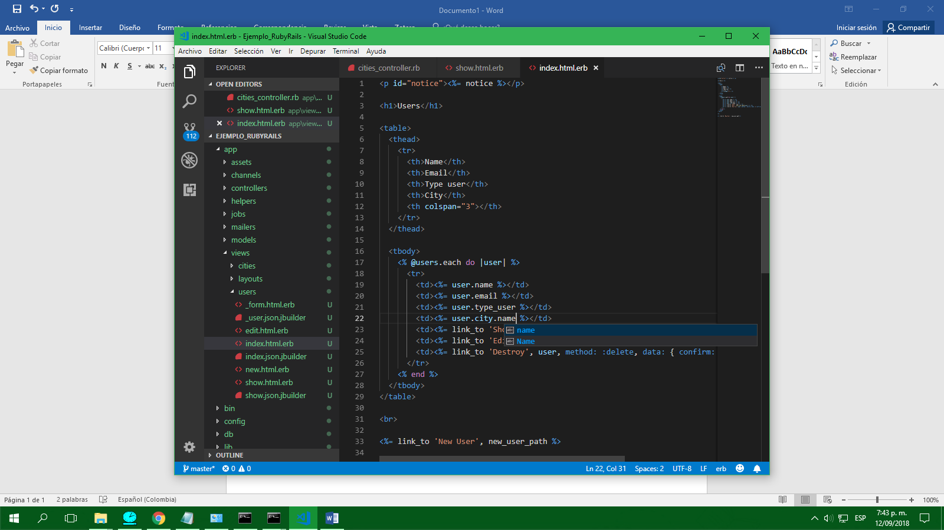

--DEFINICIÓN DE RELACIONES

Una ciudad contiene usuarios

Está vacío actualmente

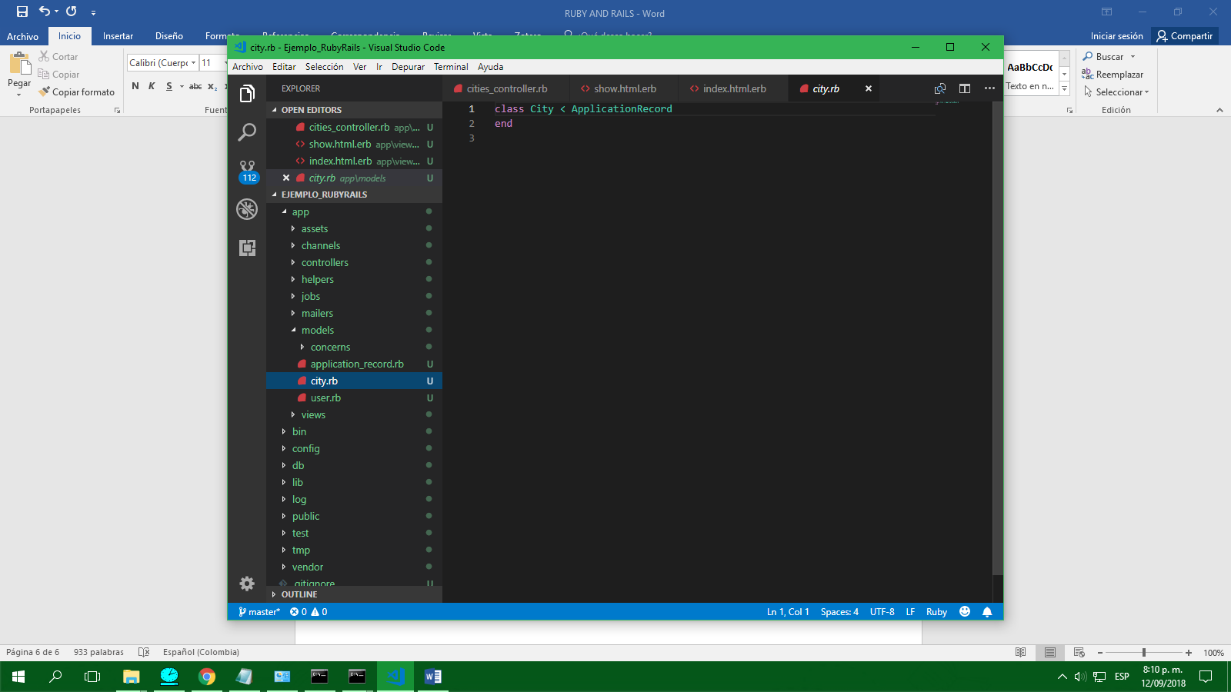

Relación de uno a muchos

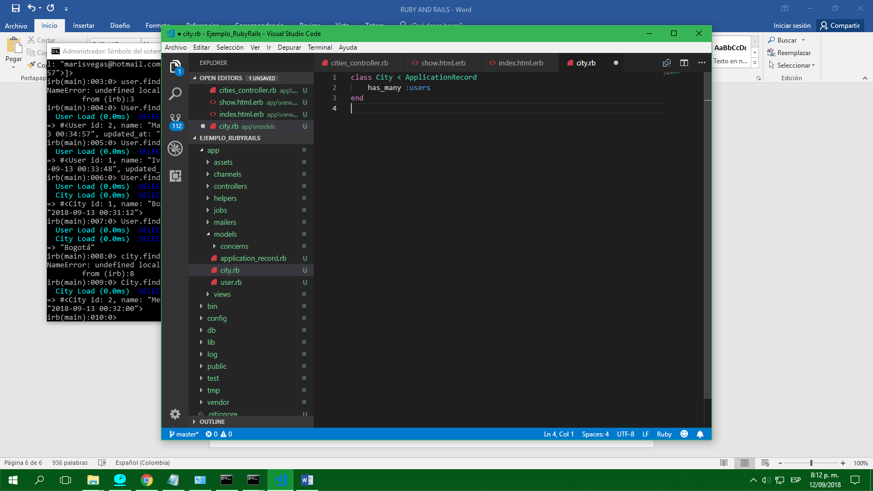

Reiniciar Rails y en consola

irb(main):009:0> City.find(2)

City Load (0.0ms) SELECT "cities".* FROM "cities" WHERE "cities"."id" = ? LIMIT ? [["id", 2], ["LIMIT", 1]]

=> #<City id: 2, name: "Medellín", zip_code: 123456, state: "Antioquia", created_at: "2018-09-13 00:32:00", updated_at: "2018-09-13 00:32:00">

irb(main):010:0> City.find.users

ActiveRecord::RecordNotFound: Couldn't find City without an ID

from (irb):10

irb(main):011:0> City.find.users

ActiveRecord::RecordNotFound: Couldn't find City without an ID

from (irb):11

--cerrar consola con ctrl+D

C:\Users\Administrador.000\Desktop\Ejemplo_RubyRails>rails console

Loading development environment (Rails 5.1.6)

irb(main):001:0> City.find(2).users

City Load (0.0ms) SELECT "cities".* FROM "cities" WHERE "cities"."id" = ? LIMIT ? [["id", 2], ["LIMIT", 1]]

User Load (0.0ms) SELECT "users".* FROM "users" WHERE "users"."city_id" = ? LIMIT ? [["city_id", 2], ["LIMIT", 11]]

=> #<ActiveRecord::Associations::CollectionProxy [#<User id: 2, name: "Mariana Vega", email: "marisvegas@hotmail.com", type_user: 2, city_id: 2, created_at: "2018-09-13 00:34:57", updated_at: "2018-09-13 00:34:57">]>

irb(main):002:0>

--VALIDACIONES EN RAILS

Vamos a validar que un usuario por obligación tenga un correo

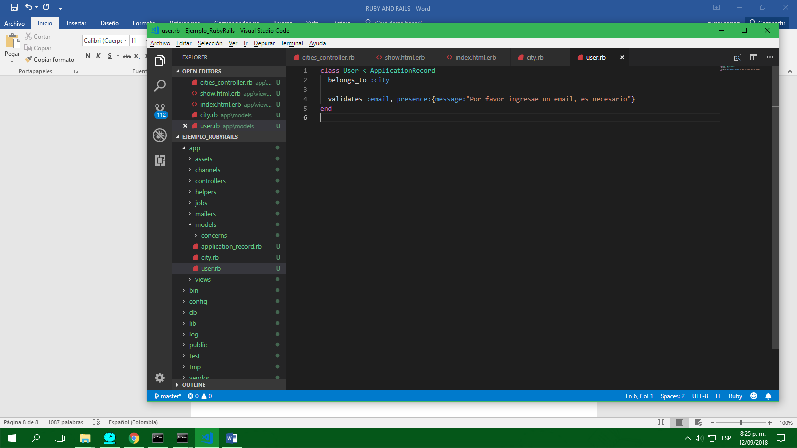

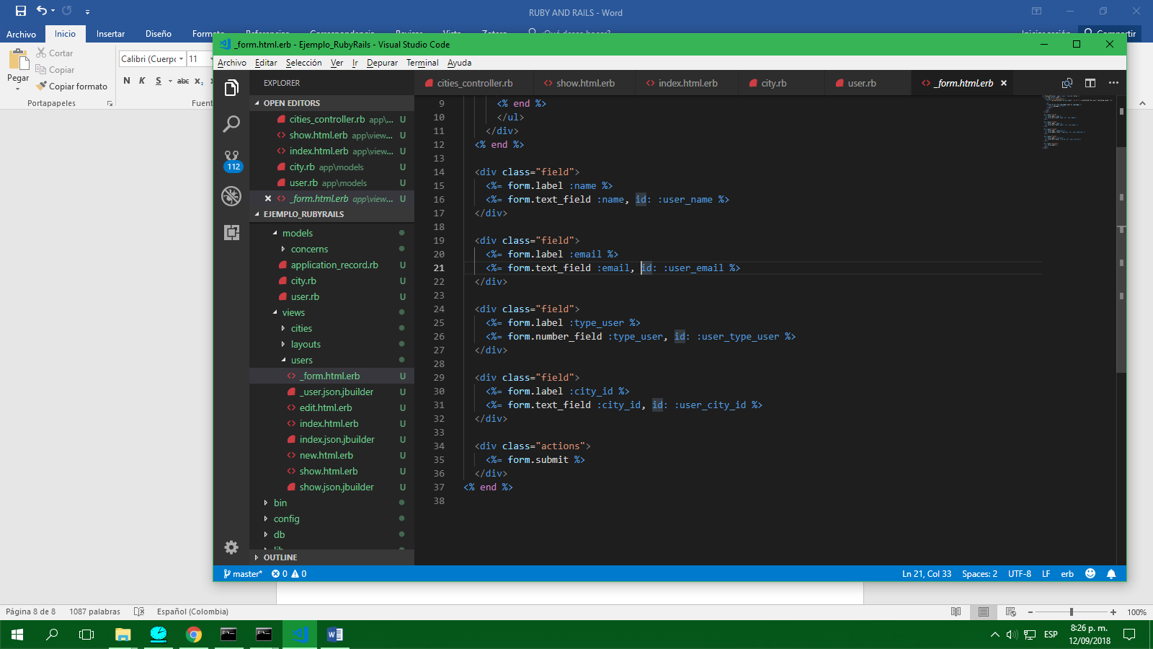

Después

